Look for an image on the internet, or use the image below, and write several sentences in which you describe the image using:

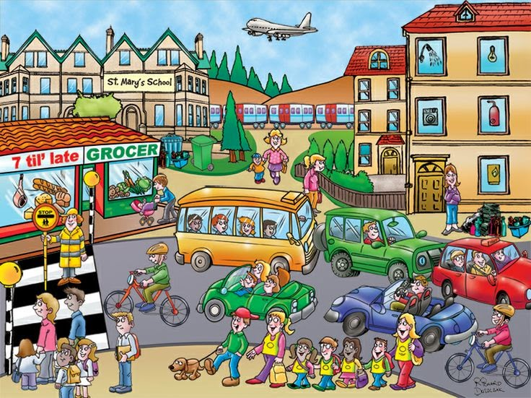
- Adjectives
- Adverbs
- Comparatives
- Possessive pronouns
- To be able to
- To be allowed to
- The tenses (present simple, present continuous, present perfect, past simple, past continuous, present passive, future)
- Much / many / little / few
- Modal verbs
On Wikiwijs Basics Unit 1, 2, 3, you can find explanatory videos about all the grammatical elements you need to know. Underneath the videos there are links to websites on which you can practise more.
On Wikiwijs Basics Extra Practise, you can find links to other websites for more practise with the grammatical structures.
On Wikiwijs Help Me! Grammar, you can find a list of the various grammatical structures with extra explanation and exercises.

